**Car Battery Essentials: Perfect Time to Fill Water**

A car battery is basically a rechargeable battery that is used for starting motor vehicles. Its major role is to supply the motor with an electric current, which initiates the chemically driven internal combustion engine and powers the motor. In other words, the electricity needed for electrical components to operate is provided by your car battery. It also transforms chemical energy into the electrical energy that runs your automobile and provides its starter with voltage. Also, it stabilizes your engine's current voltage. A car battery is an example of a wet cell battery that consists of six cells. Each cell in a plumbing battery comprises alternating plates of a grid of plumbing alloy filled with sponge plates or covered by plaster dioxide (anode). Each cell contains an electrolyte-filled sulfuric acid solution.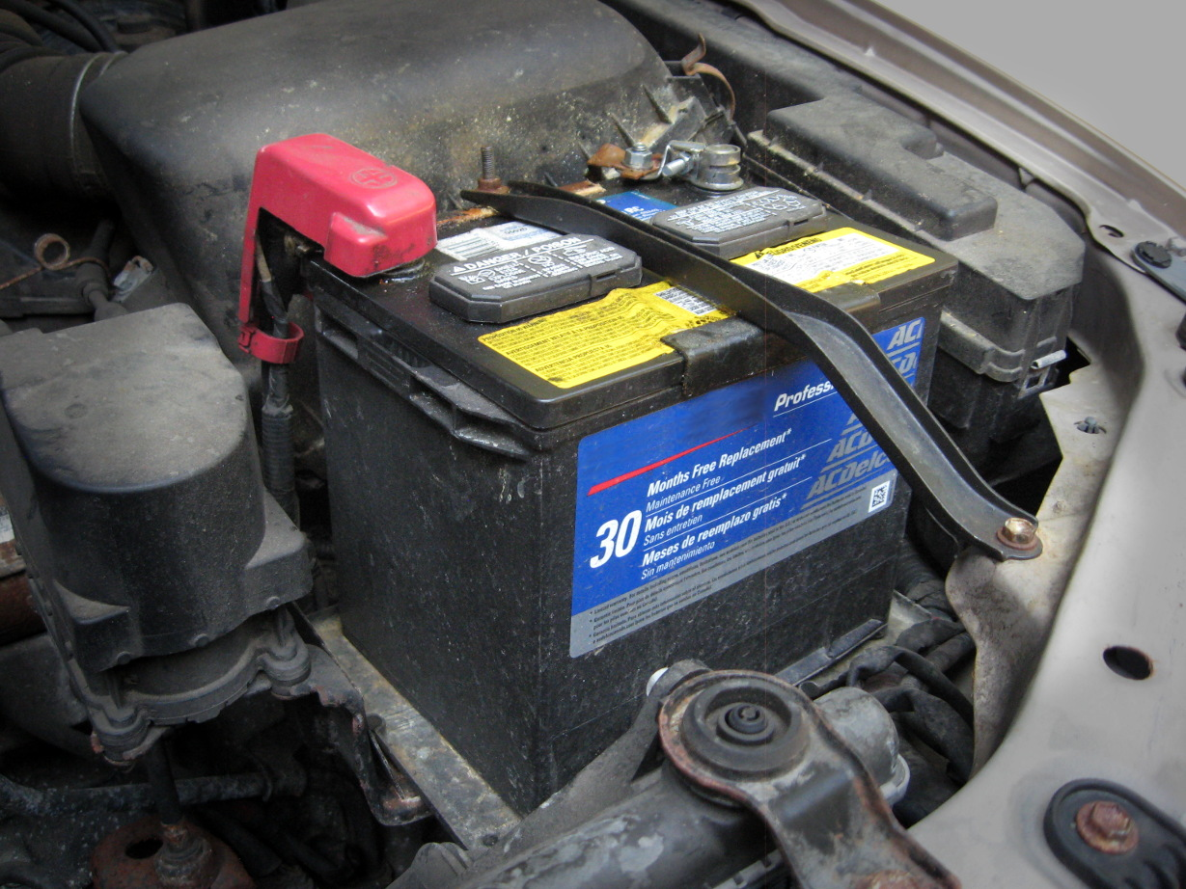

We know that man is mortal. Like a human being, each and every material has to be destroyed one day. Your automobile battery usually has a life expectancy between four and six years. Various factors impact how long your battery lasts, such as circumstances, the type of vehicle, maintenance procedure, and driving patterns. There are some important things that you must focus on while maintaining your car battery properly. Turn off headlights when it's not necessary. Check wire connections of your car battery every day so that they are not loose. Try to control the battery temperature when it is extremely hot. Don't use the battery when it gets too old. These are some of the useful tips for good battery life.

Signs that will let you know when you should change your car battery are: dim lights and electrical issues, bad smell, corroded connectors, a misshapen battery case, etc. Most good-conditioned automobile batteries survive for at least two weeks without having to start and recharge the car. However, you should always start your car once a week to recharge the 12V battery if you do not want to drive the car for any reason for some time.

**Types of Battery Water**

You must use water that is distilled. This is known as deionized water and demineralized water. In principle, it is water purified to eliminate metals and minerals that might interfere with your battery procedure. Ordinary tap water should not be used. It is best to use drinkable bottled water since tap water includes minerals and natural substances that may damage the batteries. To fill your battery, use distilled or deionized water because it does not include the tap water mineral component. Some also ask about using rainwater. Rainwater has 20 ppm and tap water has about 300 ppm to 2000 ppm. The dissolved materials are the way your battery is messed up. Tap water frequently also contains a battery-powered chemical like chlorine. In a sealed plum acid battery you may even utilize rainfall to replace water. Purchase distilled water from a hardware shop or specialized in automobile parts.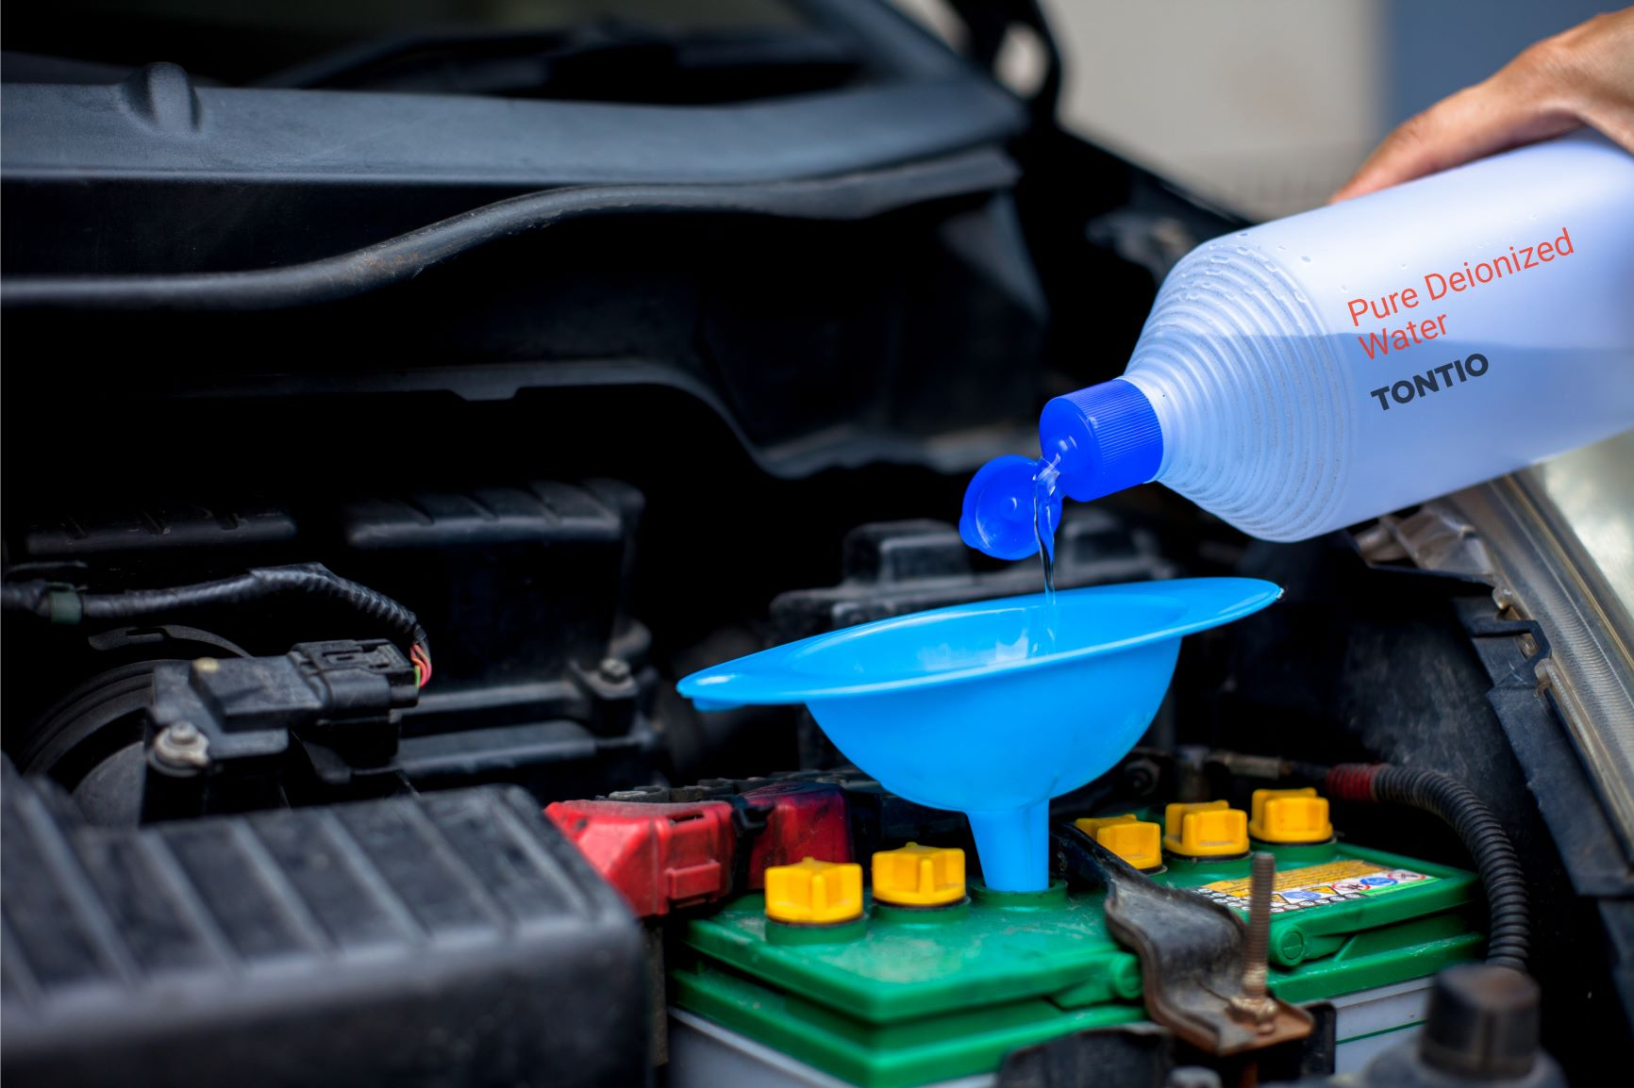

**What Causes a Battery to Lose Water?**

As the battery is charged and energy passes through the water, hydrogen, and oxygen of water are transformed into their original gasses. This gaseous process leads to a loss of water and is the direct reason why the battery has to be filled up. The reason many battery boxes are unloaded is highly flammable vapors. In fact, sealed enclosures enable the gasses to regenerate into the water, which makes up for some but not all water loss.

An industrial battery has to be hydrated, thus if the battery is not sufficiently hydrated it doesn't burn, then battery maintenance and forklift costs increase while battery life decreases. If properly maintained, an industrial battery should last up to 5 years. If this is not done, one will risk reducing up to half or two and a half years of the life expectancy of a forklift battery! Water fills the individual cells with contemporary plumage-acid batteries which operate most electric forklifts so that the chemicals and electrolytes power the machinery are a functioning mixture. If your forklift battery has too low water levels, it might cause avoidable harm to your equipment. If you load the battery with too much water, it might pour-over. When a battery overflows, a few of the acids inside the battery lose their shelf life dramatically. When charging, the battery needs extra room for fluid expansion. Ensure that the amount of water is high enough to cover the platforms within the cells. This keeps your battery properly.

**Perfect Time to Fill Your Battery**

Some batteries include a clearly labeled "eye" battery indicator on the top that shines green when the water level is good and completely charged. If it is yellow, the battery fluid level is frequently low or the battery faulty. While the batteries should only be replenished when fully charged, the water level should also be checked before charging to verify that sufficient water is available. Add sufficient water after charging to bring the level to the bottom, roughly three-fourths below the cell's top. Some people can run your automobile 24/7, while others can only operate once a week. Ideally, once or once a day you want to hydrate your battery. The optimum time to hydrate your battery is always shortly before every shift after cooling. The worst time to water is right before or during charging.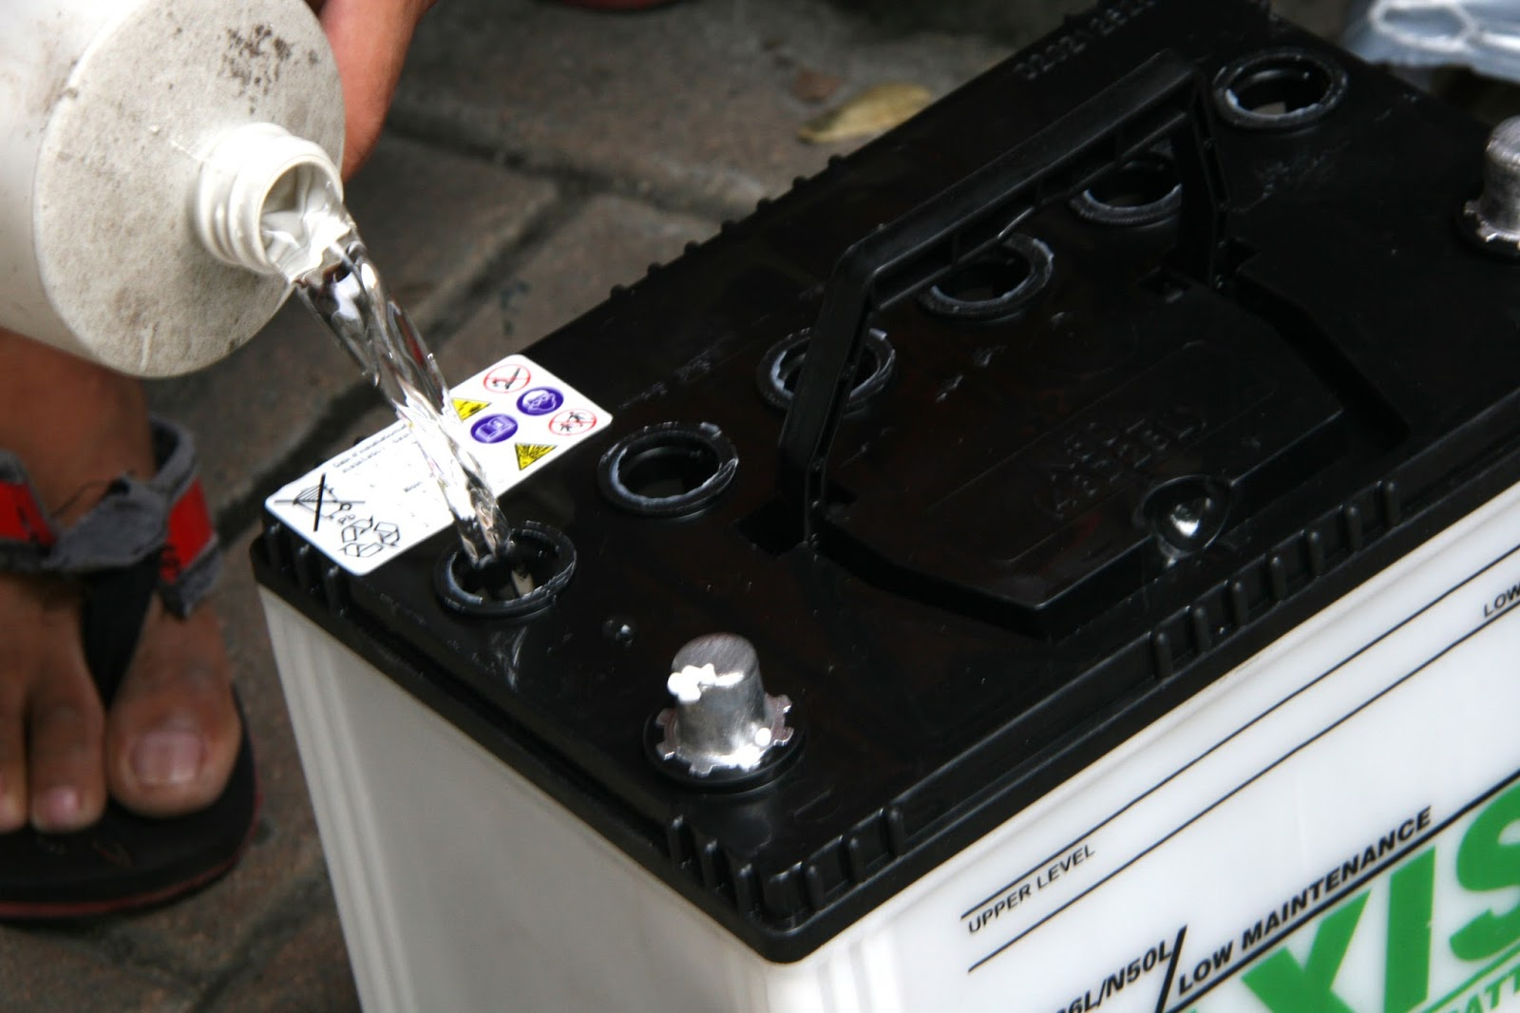

**Cautions About Battery Water**

You need to be very much careful while operating with battery water. When too much water has been added to the battery before charging, the electrolyte level expands and damages the battery. In addition, excessive battery watering can cause extra electrolyte depletion, which results in lower battery power. Overwatering can lead to dilution of the electrolytes and a decrease in performance. Avoid topping it off while the water levels are in a reasonable range. Subsequently, sulfation can occur for underwatering. Sulfation occurs when battery plates start to develop sulfate crystals. Longer charge durations, power loss, and early failure are caused by sulphurization. Most of the car batteries are sealed and maintenance-free. They do usually have a water level indicator that will allow you to observe if the water level is good.